COLUMBIA ASIA PROJECT
POWER BI PROJECT
Objective and Subjective Questions
Prepared by: AISHIK DALUI
Course: Professional Certificate Course In Data Science – January 2026

Introduction
This project is about taking the raw data from Columbia Asia Hospital and turning it into something useful, using a mix of Power BI and SQL. The main idea was to get a clear picture of how patients behave, how each department is performing, how individual doctors are doing, what drives satisfaction, and how efficiently the hospital runs overall. The data itself covers patient demographics, visit records, waiting times, satisfaction ratings, billing details, and doctor-patient interactions, which together give a fairly complete, all-round view of hospital performance.
Before jumping into any analysis, a good amount of time went into cleaning and preparing the data so the results could actually be trusted. That meant checking that every column had the right data type, dealing with missing values (especially in the satisfaction score column), splitting the date-time field into separate date and time columns, and building a few new calculated columns like age groups, gender labels, and full patient names to make the data easier to work with. All these transformation steps were done using M-query in Power BI, which also kept a clear, traceable record of exactly what was changed and why.
Once the data was ready, a set of visuals was built in Power BI to explore patient distribution, age-group behaviour, patterns across races, satisfaction trends, revenue, and how different doctors were performing. DAX was used quite heavily here — for departmental revenue, comparing appointment fees, tracking visit trends, working out satisfaction averages, and looking at demographic relationships. On top of that, SQL queries were written for the more rule-based, deeper questions, like finding the top-performing doctors, comparing revenue by gender, checking how diverse each doctor's patient base is, and tracking waiting-time trends across several months.
Together, this Power BI and SQL approach helped surface the operational bottlenecks, the departments that are doing well, how individual doctors compare, and where there's room to improve. The end goal was to hand the hospital's management a set of practical insights they can actually act on — things that support better decision-making, improve patient satisfaction, help plan staffing, and generally make the hospital run more smoothly.
Objective Questions
- In analyzing the hospital dataset with Power BI, ensure data cleaning to address inconsistencies and missing values before further analysis.
Answers –
- The first thing I did was go through each column and check its data type against the schema — everything was already set correctly, so no changes were needed there.
- The "patient sat score" column had a number of null values, and leaving them as-is could have caused errors later on, so I replaced them with 0 to keep the data consistent.
- The date column had both the date and the time bundled together, so I split it into two separate columns to make the analysis easier.
- Since the dataset only had initials for first and last names, I combined the two into a single "Patient Name" column, which made things a lot easier to read and work with.
- I also created a new "Gender" column that spells out M and F as "Male" and "Female" so it's clearer at a glance.
- Assess the Average Waiting Time: Analyse the patient wait times to identify the average duration a patient spends before receiving care.
Answers –
On average, patients wait about 35.26 minutes before receiving care.
FORMULA USED => Average Waiting Time = AVERAGE ('Hospital ER (1)'[patient_waittime])
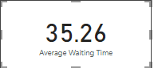
- Visits by Department Referral: Calculate the total number of visits to each department based on referrals to understand which departments are most frequently visited.
Answers –
Insights:
- The chart below breaks down patient visits by department referral.
- General Practice sees by far the most patients, at around 7.2K.
- Renal gets the fewest, at just 0.1K.
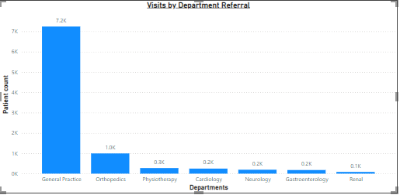
- Patient Visits by Age Group: Segregate patient visits according to different age groups to see which demographics utilize healthcare services the most.
Answers –
Insights:
- The visual shows patient counts across the different age brackets.
- The 0-18 age group has the highest count, with 2,110 patients.
- The 66+ group has the fewest, at 1,617.
Approach used:
- I built an "Age Group" custom column in Power BI to bucket patients based on their age.
- Formula used for the custom column:
if [patient_age] <= 18 then "0-18"
else if [patient_age] <= 35 then "19-35"
else if [patient_age] <= 50 then "36-50"
else if [patient_age] <= 65 then "51-65"
else "66+"
- Then I used a column chart with the age group and patient ID fields to visualize the split.
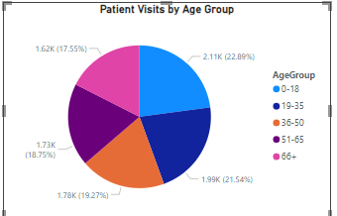
- Were there any Null values in the data? What would be the best way to handle these Null values and which approach have you opted for?
Answers –
- Yes — the "patient sat score" column had null values.
- There are a few different ways to handle nulls, and the right one really depends on the situation. For a numeric field like age, for instance, you could fill the gaps with the column's average.
- The most common approach is to just drop rows with nulls, but that comes with a downside — you'd lose the entire row, which might mean losing other useful data along with it.
- In this case, dropping the nulls in "patient sat score" would've meant losing a lot of important data, since most of the column was actually null. That also meant an average wouldn't have been reliable anyway, so I went with replacing the nulls with 0 instead — this kept things error-free and usable for calculations.
- Is there any relation between the number of visits and the Gender of the patients?
Answers –
Insights:
- Looking at the visual, gender doesn't really seem to affect the number of visits.
- Male (4.5K) and Female (4.7K) patients are pretty close in numbers, no major gap there. There's also an "NC" category with 24 patients that isn't defined anywhere in the schema — my best guess is these are patients who simply didn't fill in their gender. Either way, the count is so small it doesn't change the overall picture.
- So overall, there's no meaningful relationship between gender and visit count.
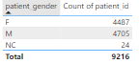
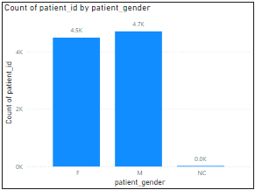

- Average Satisfaction by Demographics: Determine the relationship between patient satisfaction scores, their age groups, and racial backgrounds to pinpoint areas for improvement in patient experience.
Answers –
Insights:
- Since a large chunk of the satisfaction data was null, a straightforward average wouldn't have given an accurate picture.
- So I built a measure that calculates the average satisfaction score while excluding the null (0) values. If those zeros were included, the average would drop to somewhere around 1-2, which would unfairly make the hospital look much worse than it actually is.
- The ratings scale runs from 1 to 10, and once the nulls are excluded, the average comes out to around 5.47 — a fairly middling score. The visual helps break this down further by age group and race, giving a sense of where the hospital could focus its efforts to improve patient experience.
Approach used:
- I used the age group column and the race column together with the average satisfaction score measure to build a clustered column chart, which makes the relationship between these three factors easy to see.
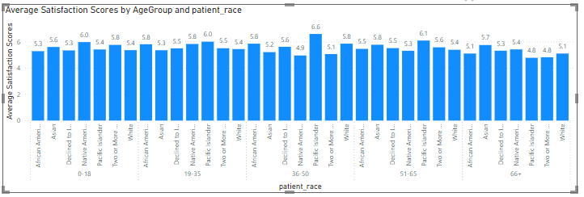

- The hospital's managing director seeks to evaluate the revenue of each department to understand how much revenue is generated by each.
Answers –
Insights:
- The visual below shows the revenue generated by each department.
- Orthopaedics is the top earner, generating around 173M.
- Renal generates the least, at around 5M.
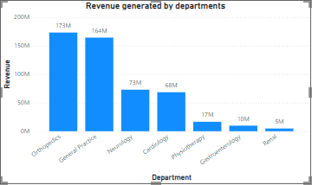

- Which department is charging the highest appointment fees in general? Use an aggregation DAX function to solve this question.
Answers –
FORMULA USED => Department with Max Fee =
VAR MaxFee = MAXX(ALL(Sheet), Sheet[Appointment Fees])
RETURN
CALCULATE(
FIRSTNONBLANK(Sheet[department_referral], 1),
Sheet[Appointment Fees] = MaxFee)
Insights:
- Neurology comes out on top, with the highest appointment fee at 1500.


- Create a tabular visualization in the Report view which consists of Month-wise total visits in the hospital. Add a third column in the table that consists of the previous month’s total visits for each month’s row. Also, include a column that states whether the visits in a month are greater than that of the previous month's visits.
Answers –
Insights:
- The table lets you compare each month's visit count against the previous month's.
- A "Status" column then flags whether visits went up or down from one month to the next.
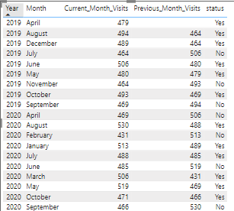

- Using ‘Calculate’ and a row iteration DAX function calculate the total number of patients who have visited Dr. Smith.
Answers –
Patient count for Dr Smith = 5986
FORMULA USED => Patient Count for Dr Smith =
CALCULATE(COUNT(Sheet[patient_id]), Sheet[Doctor Name] = "Dr. Smith")
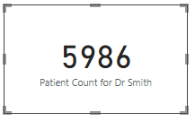

- Calculate the average age of the patients who visit the Orthopedics department. Will the approach used to calculate this metric be different if the requirement had been all departments’ average age?
Answers –
FORMULA USED => Average age of Orthopedics Patients =
CALCULATE(AVERAGE('Hospital ER'[patient_age]),'Hospital ER'[department_referral] = "Orthopedics")
Insights:
- The average age of Orthopedics patients works out to 38.66.
- If I needed the average age across all departments instead, I wouldn't need CALCULATE at all, since there'd be no condition to filter by — a plain AVERAGE would do the job:
  - Average age of departments = AVERAGE ('Hospital ER'[patient_age])
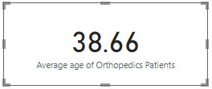

- Were there any data format issues in the data, and if there were/are how you handle them?
Answers –
Overview:
- After going through the dataset, I didn't come across any real data format issues.
- The patient wait time was stored as a number, and per the schema that number represents minutes, so that was already correct.
- The new columns I created during the analysis were also given the correct data types.
- If something like the date-time column had the wrong data type, I would've just corrected it to the right format to keep the analysis accurate and error-free.

- When we add a column in Power Query what’s the code that comes in M language in the formula bar? What do you know about M-query?
Answers –
Overview:
- M-query is the language behind Power Query in Power BI, and it's what handles the data transformation.
- It's a functional language, so it works by applying functions and transformation steps to reshape the data.
- Whenever you add a new column in Power Query, it automatically generates the corresponding M code in the formula bar. That code is essentially what drives each transformation step, and it also makes it easy to track exactly what's being done to the data.

- Identify the top 5 doctors who generated the most revenue but had the fewest patients. (SQL)
Answers –
Query:
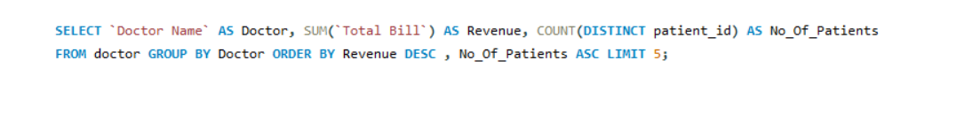
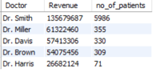

- Find the department where the average waiting time has decreased over three consecutive months. (SQL)
Answers –
Query:
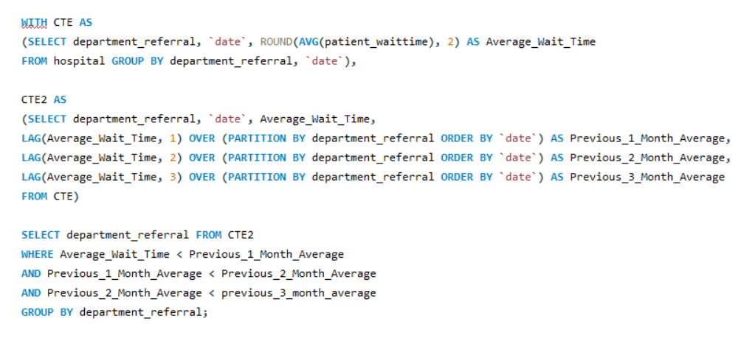
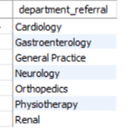

- Determine the ratio of male to female patients for each doctor and rank the doctors based on this ratio. (SQL)
Answers –
Query:
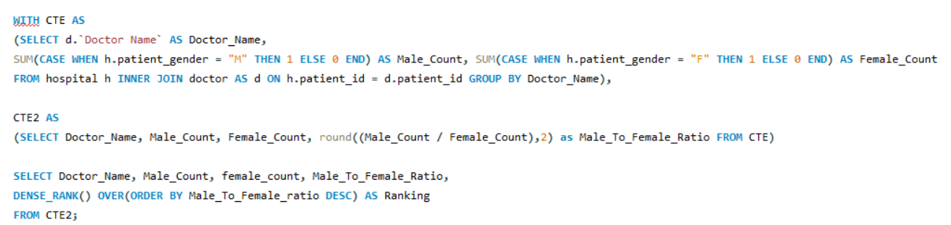
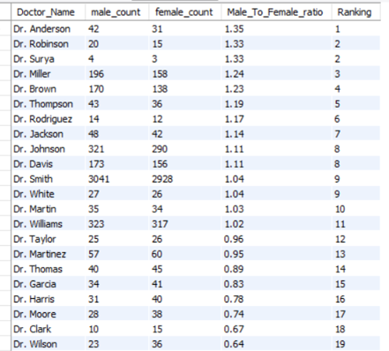

- Calculate the average satisfaction score of patients for each doctor based on their visits. (SQL)
Answers –
Query:
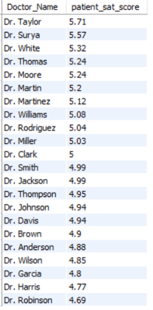

- Find doctors who have treated patients from different races and calculate the diversity of their patient base. (SQL)
Answers –
Query:
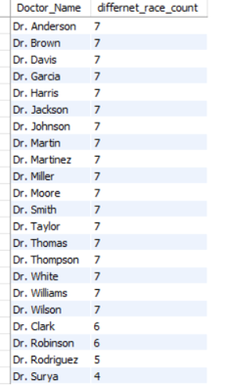

- Calculate the ratio of total bills generated by male patients to female patients for each department. (SQL)
Answers –
Query:
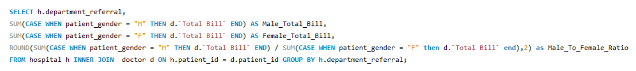
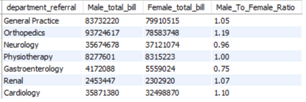

- Update the patient satisfaction score for all patients who visited the "General Practice" department and had a waiting time of more than 30 minutes. Increase their satisfaction score by 2 points, but ensure that the satisfaction score does not exceed 10. (SQL)
Answers –
Query:
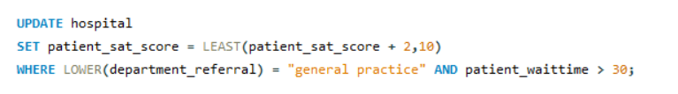
Subjective Questions
- What is the relation between patient wait time and satisfaction scores?
Answers –
Insights:
- The chart below shows how wait time and satisfaction score relate to each other.
- Satisfaction stays fairly steady across most wait times, but it peaks at the 10-minute mark (6.70) and dips lowest around the 40-minute mark (4.53).
- That said, these numbers should be taken with a pinch of salt — about 75% of the ratings were missing, so this is based on just the remaining 25%. It'd help if the hospital encouraged more patients to actually leave a rating, so future analysis can be more reliable.
Approach used:
- I used a scatter chart plotting wait time against the average satisfaction score measure.
- I went with the average satisfaction measure (which excludes nulls) since 75% of the ratings were missing — using just the remaining 25% still gives a reasonably useful picture.
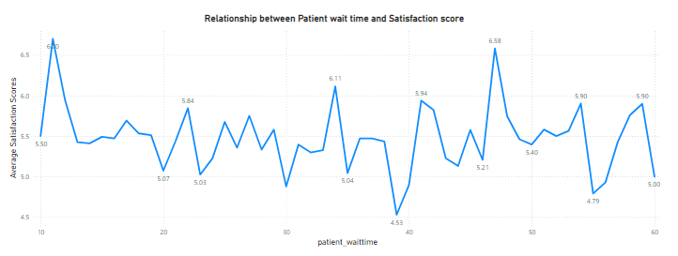
- How do patient demographics affect the frequency of visits to different departments?
Answers –
Insights:
- The visuals below break down patients by department, based on both age and race.
- This gives a clearer picture of who's actually using each department.
- It can also guide decisions on improving facilities based on what the demographics show.
Approach used:
- I used a stacked column chart to show how patients are distributed.
- The chart pulls together department referral, age group, race, and patient count.
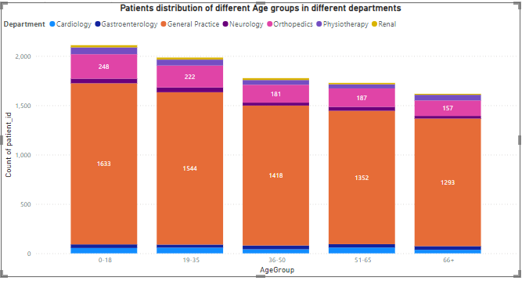
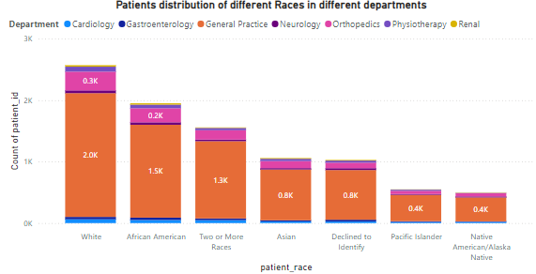
- Is there a noticeable trend in the volume of patient visits throughout the year?
Answers –
Insights:
- The visual shows how patient visits changed over the course of the year.
- Visits peaked in August 2020, at 530.
- The lowest point was February 2020, at 430.
- Beyond that, it's hard to call out a clear trend since the data itself is a bit inconsistent, which limits how much can be read into it.
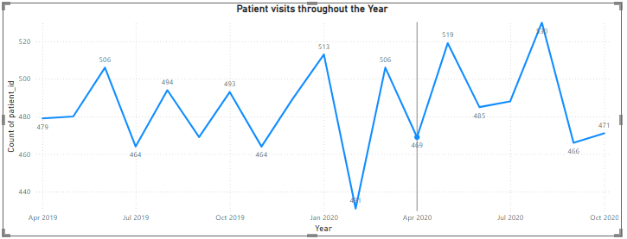

- Which age groups report the highest and lowest satisfaction scores?
Answers –
Insights:
- The chart below shows satisfaction scores broken down by age group.
- I built this using a line chart with the average satisfaction score measure against the age group column.
- The 36-50 age group reports the highest satisfaction, at 5.64.
- The 66+ age group reports the lowest, at 5.14.
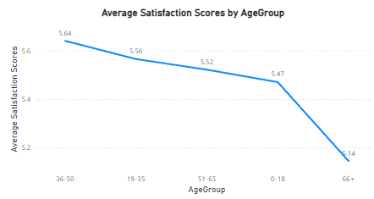

- Say someone outside of the hospital claims that there is racial or gender-based discrimination in the hospital, how will you identify whether the claim was right or not?
Answers –
Insights:
- Looking at the patient distribution, there isn't a meaningful gap between the number of male and female patients.
- The average waiting time by race also shows all races being treated pretty similarly, with no group waiting noticeably longer than another.
- Together, this suggests care is being delivered fairly across gender and race, with no real evidence of discrimination in either area.

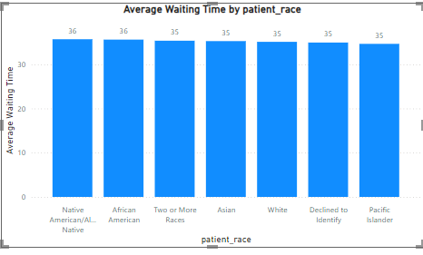

- The hospital management intends to offer discounts to patients. How should these offers/discounts be assigned to patients, on what basis, and why?
Answers –
Insights:
- The chart shows revenue by department.
- Neurology (0.38M) and Cardiology (0.28M) bring in the most revenue, which points to them having a solid volume of patient visits.
- We also know from earlier that Neurology has the highest appointment fee, at 1500.
- Taking all of this together, Neurology and Cardiology look like the right departments to offer discounts in.
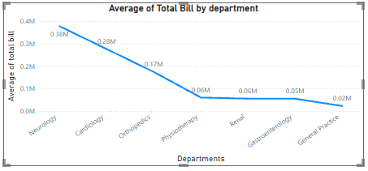
- The hospital has a budget to hire 2-3 new doctors. They have asked for your suggestions on which departments they should hire.
Answers –
Insights:
- The visual shows patient counts across departments.
- General Practice leads with about 7.2K patients, followed by Orthopedics at around 1.0K.
- Renal has the fewest, at just 0.1K.
- Given this, new doctors should go to the departments handling the most patients.
- That would mean General Practice, Orthopedics, and Physiotherapy.
- General Practice in particular only has 3 doctors covering roughly 7.2K patients, so it's the department that needs new hires the most.
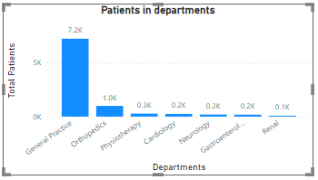
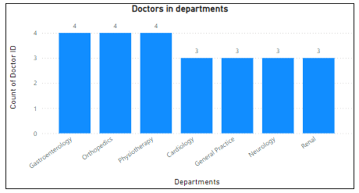

- Is the hospital profitable? How will you determine the profitability?
Answers –
Overview:
- Unfortunately, the dataset doesn't include things like doctor salaries, maintenance costs, or staff salaries.
- We can calculate the revenue side, but not the operational costs, since that data isn't available.
- So this particular question can't really be answered with the data on hand.
- Are there any departments with unusually long waiting times compared to the others?
Answers –
Insights:
- The chart shows average wait time by department.
- Wait times are fairly consistent across the board.
- So no single department stands out with an unusually long wait time.
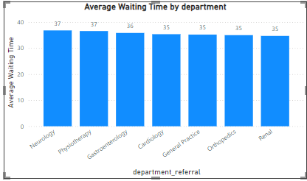

- Any Department for which the waiting time is oddly large?
Answers –
Overview:
- As mentioned earlier, Neurology and Cardiology are the top revenue-generating departments and also carry higher appointment fees.
- That makes them a good fit for discount offers.
- The hospital could run periodic medical campaigns offering discounts on select days, which would also help bring in more patients.
- This approach could work well for both sides — it helps the hospital maximize revenue while also making healthcare more affordable for patients.

- Come up with strategies to provide discounts to the patients.
Answers –
Insights:
- The visual shows patient distribution across morning and evening timings.
- Mornings see more patients (4.8K) than evenings (2.4K).
- We already know General Practice only has 3 doctors, which is a heavy workload for that few people and likely hurts how efficiently they can work.
- So bringing in additional doctors and splitting everyone across two shifts would let them get proper rest and work more effectively.
- A two-shift policy would genuinely help here — in healthcare, even small lapses can have serious consequences, so making sure doctors get enough rest through proper shift planning would go a long way in keeping them sharp and effective.
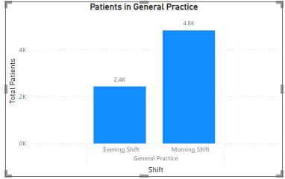

- Say you need to align the doctors of the “General Practice” department to work in one of the two shifts, how will you identify what will these two shifts' timings be, and how will you divide the doctors in these two shifts? And also will this 2 shift policy be helpful for the hospital?
Answers –
Insights:
- A Power BI Gateway basically acts as a bridge, securely connecting on-premises data sources to the Power BI service in the cloud.
- It lets you work with on-premises data without actually having to move that data to the cloud.
- It also handles secure, seamless data refreshes, so cloud-based reports and dashboards stay in sync with data sitting on local servers.
Use cases:
- Scheduled Data Refresh
- Real-Time Data Access (Direct Query)
- Access to On-Premises Data
- Sharing and Collaboration with On-Premises Data

- How would you approach this problem, if the objective and subjective questions weren't given?
Answers –
Without the guidelines, here's roughly how I'd have gone about it:
- Start by cleaning the data — checking that every column has the right data type.
- Deal with missing values using whatever method fits best, and split date and time into separate columns for easier analysis.
- Set up a dedicated table to hold all the DAX measures, just to keep things organized.
- Build out some basic metrics first, look at what they show, and then build on that for deeper analysis.
- Create visuals based on what the business would actually care about — things like doctor counts per department, revenue by department, and so on.
- And finally, pull everything together into one clear, informative report.

- Can you analyze and write the type of relationship between the doctor id and department, is it one-to-one?
Answers –
Overview:
- No, it isn't one-to-one.
- It's actually a one-to-many relationship.
- That's because a department like General Practice can have several doctors working in it, while each doctor is generally tied to just one department at a time.
Conclusion
Overall, this project gives a fairly complete picture of how Columbia Asia Hospital is performing, bringing together Power BI dashboards with SQL-based analysis. After cleaning, transforming, and visualizing the data, some clear patterns emerged around patient demographics, how workload is spread across departments, satisfaction scores, revenue by department, and how efficiently patients are being seen. The SQL side added another layer, digging into things like the top-earning doctors, how diverse each doctor's patient base is by gender and race, revenue ratios, and trends over time that wouldn't have been as obvious from the dashboards alone.
A few things stood out from the findings: busy departments like General Practice and Orthopedics really do need more doctors to handle the patient load properly, while quieter departments like Renal see very few visits. Satisfaction scores shift depending on age group and are closely tied to waiting time, though the missing rating data does limit how far that analysis can go. On the revenue side, Orthopaedics and Neurology are the clear leaders, which is useful for decisions like where to offer discounts or how to allocate resources. And importantly, nothing in the data pointed to any gender or racial bias — waiting times and visit counts stayed consistent across every group.
In short, this project takes raw hospital data and turns it into something management can actually use to make decisions. It's a good example of how data analytics can help a hospital improve patient experience, plan its workforce better, prioritize where to focus, and generally run more efficiently. By pairing Power BI's visuals with the precision of SQL, this analysis lays a solid groundwork for data-driven decisions across the hospital.
Thank you for taking the time to go through my project.
I hope I've been able to do justice to all the questions asked here.
AISHIK DALUI

